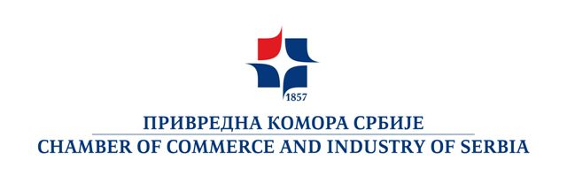

SERBIAN BUSINESS DELEGATION VISITING ZAMBIA
(September 10 -11, 2015.)

P R I J A V N I L I S T

COMPANY NAME

ADDRESS

TAX NUMBER (PIB)
REGISTRY CODE (matični broj)
REPRESENTATIVES’ NAME, POSITION AND PASSPORT NO
(imena putnika, funkcija i broj pasoša)
TEL.
FAX.
E-MAIL
WEB SITE
OWNERSHIP

COMPANY’S CORE ACTIVITIES
INTEREST FOR COOPERATION WITH PARTNERS FROM ZAMBIA

INDICATE PROFILE OF COMPANIES AND/OR INSTITUTIONS YOU WOULD LIKE TO CONTACT IN ZAMBIA
OTHER SUGGESTIONS AND /OR COMMENTS AND/OR REFERENCES IN ZAMBIA

Molimo da prijavni list popunite na engleskom jeziku i prosledite najdalje do 28. 08. 2015.godine na e-mail: ivana.bajic@pks.rs i milja.miljanovic@pks.rs

