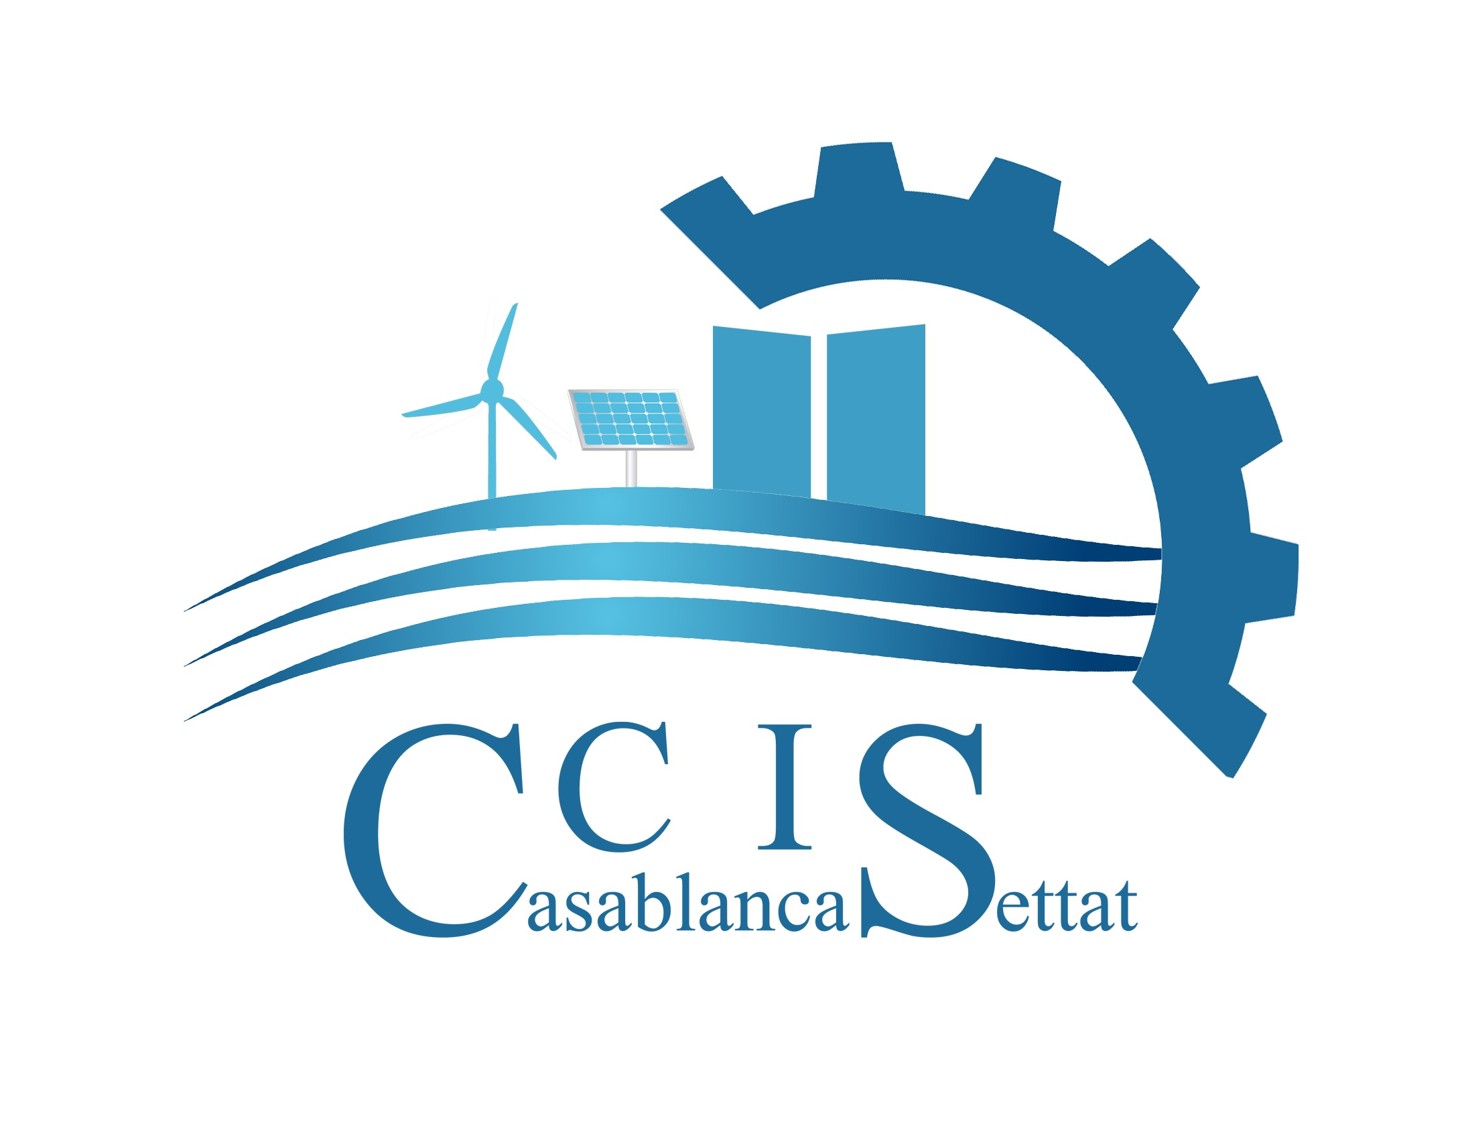

ONLINE CONFERENCE (via ZOOM)

Chamber of Commerce and Industry of Vojvodina (Serbia)
and
Casablanca Chamber of Commerce (Morocco)

February 23rd, 2021
11:00 – 14:00 CET

PROGRAMME

10:45 – Press Conference

Time | Topic | Speaker
11:00 | Welcoming remarks | Mr. Bosko Vucurevic, president of the Chamber of Commerce and Industry of Vojvodina
11:15 | Welcoming remarks | H.E. Mr. Mohammed Amine Belhaj, Ambassador of The Kingdom of Morocco to Serbia
11:30 | Welcoming remarks | Mr. Yassir Adil, president of Casablanca Chamber of Commerce
11:45 | Presentation of the Chamber of Commerce and Industry of Vojvodina and Vojvodina region | Jelena Bjelanovic, secretary to the Cabinet, Chamber of Commerce and Industry of Vojvodina
12:00 | Business climate and investment in the Casablanca-Settat region | Regional Center for investment, Casablanca
12:15 | Agriculture sector in Vojvodina region | Mladen Petkovic, Agriculture Association secretary, Chamber of Commerce and Industry of Vojvodina
12:30 | Investment opportunities in Morocco | Maroccan Agency for Development of Investments and Export
12:45 | Industry sector in Vojvodina region | Zoran Trpovski,  Industry Association secretary, Chamber of Commerce and Industry of Vojvodina
13:00 | Tourism in Morocco | Regional Tourism Council, Casablanca
13:15 | Services sector in Vojvodina region | Branislav Mamic,  Services Association secretary, Chamber of Commerce and Industry of Vojvodina
13:30 | Concluding remarks | H.E. Mr. Mohammed Amine Belhaj, Ambassador of The Kingdom of Morocco to Serbia
13:40 | Concluding remarks | Mr. Yassir Adil, president of Casablanca Chamber of Commerce
13:50 | Concluding remarks | Mr. Bosko Vucurevic, president of the Chamber of Commerce and Industry of Vojvodina

Moderator: Milan Stojanov, chief of the President’s Office Staff, Chamber of Commerce and Industry of Vojvodina

Working language: English

***

Live on YOUTUBE PKV channel page (LIVE button)

https://www.youtube.com/c/PrivrednakomoraVojvodine/

