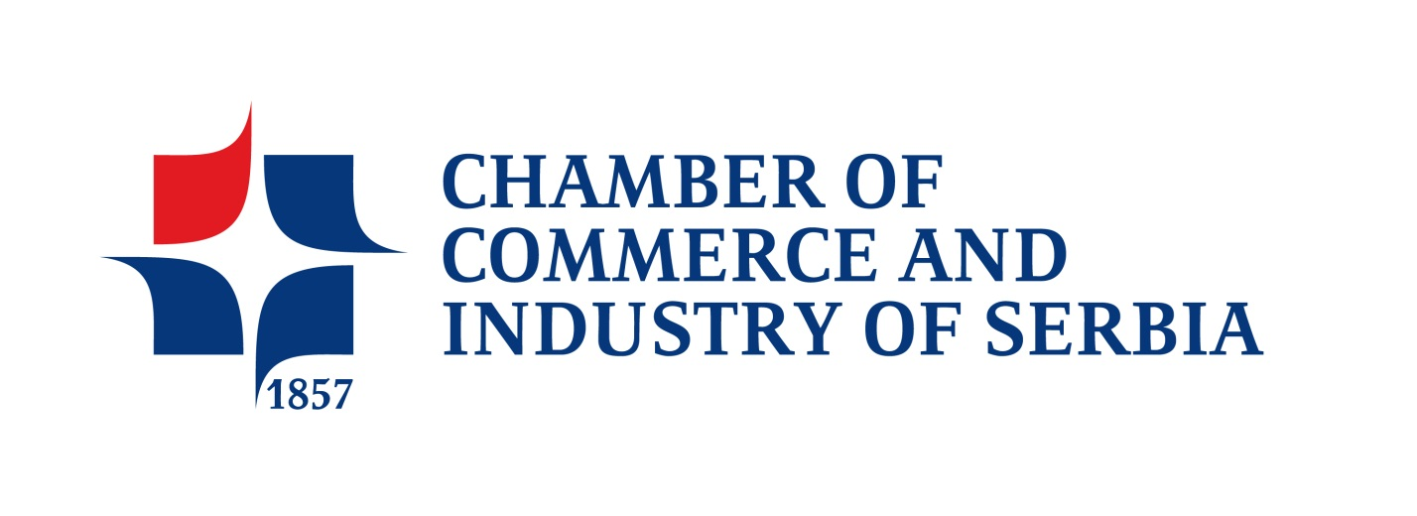

Business Forum Serbia - Romania
Bucharest, 06 March 2014

APPLICATION FORM

Napomena: Ponuda agencije Royaltours za cenu aranžmana koja je navedena u pismu važi do 10.02.2014.g.

COMPANY NAME

ADDRESS

TAX IDENTIFICATION NUMBER (PIB)
REGISTRY NUMBER (matični broj)
NAME AND POSITION OF THE COMPANY REPRESENTATIVE

TEL
MOB. TEL
FAX
E-MAIL
WEB SITE
OWNERSHIP

BRIEF DESCRIPTION OF YOUR COMPANY ACTIVITY
INTEREST FOR COOPERATION WITH ROMANIAN PARTNERS (contact with importers, exporters, producers, etc…)

Molimo Vas da prijavni list popunite na engleskom jeziku i dostavite na e-mail: bojana.ruzic@pks.rs , kontakt telefon 011/3231-027

